# **Malaria Parasite Detection**

**Developed by**

MAINAK MONDAL

SOUGATA DOLAI

DEBJIT DEBNATH

SOUMIK SARKAR

**Under the Supervision of**

Dr. BISWAJIT HALDER

Assistant Professor, CSE

29/04/2020

## **Malaria Parasite Detection**

**A Dissertation Submitted in partial fulfillment for the**

**Degree of Bachelor of Technology (B.TECH), 6th Semester**

**In Computer Science & Engineering**

**Submitted by**

| **Name** | **University Registration Number** | **University Roll Number** |
| --- | --- | --- |
| MAINAK MONDAL | 171270110051 of 2017-2018 | **430117010085** |
| SOUGATA DOLAI | 171270110097 of 2017-2018 | **430117010087** |
| DEBJIT DEBNATH | 171270110034 of 2017-2018 | **430117010096** |
| SOUMIK SARKAR | 171270110100 of 2017-2018 | **430117010107** |

**Under the Supervision of**

**Dr. BISWAJIT HALDER**

**Assistant Professor, CSE**



**Narula Institute of Technology**



**Maulana Abul Kalam Azad University of Technology**

**(April, 2020)**

## **CERTIFICATE OF ORIGINALITY**

The project entitled “Malaria Parasite Detection” has been carried out by ourselves in partial fulfillment of the degree of Bachelor of Technology in Computer Science & Engineering of Narula Institute of Technology, Agarpara, Kolkata under Maulana Abul Kalam Azad University of Technology during the academic year 2020-2021.

While developing this project no unfair means or illegal copies of software etc. have been used and neither any part of this project nor any documentation have been submitted elsewhere or copied as far in our knowledge.

Signature:

Name: MAINAK MONDAL

University Roll No.: 430117010085

University Registration No.: 171270110051 of 2017-2018

Signature:

Name: SOUGATA DOLAI

University Roll No.: 430117010087

University Registration No.: 171270110097 of 2017-2018

Signature:

Name: DEBJIT DEBNATH

University Roll No.: 430117010096

University Registration No.: 171270110034 of 2017-2018

Signature:

Name: SOUMIK SARKAR

University Roll No.: 430117010107

University Registration No.: 171270110100 of 2017-2018

## **CERTIFICATE OF APPROVAL**

This is to certify that the project entitled “Malaria Parasite Detection” has been carried out by Mainak Mondal, Sougata Dolai, Debjit Debnath and Soumik Sarkar under my supervision in partial fulfillment for the degree of Bachelor of Technology (B.TECH) in Computer Science & Engineering of Narula Institute of Technology, Agarpara affiliated to Maulana Abul Kalam Azad University of Technology during the academic year 2020-2021.

It is understood that by this approval the undersigned do not necessarily endorse any of the statements made or opinion expressed therein but approves it only for the purpose for which it is submitted.

Signature:

Name: MAINAK MONDAL

University Roll No.: 430117010085

University Registration No.: 171270110051 of 2017-2018

Signature:

Name: SOUGATA DOLAI

University Roll No.: 430117010087

University Registration No.: 171270110097 of 2017-2018

Signature:

Name: DEBJIT DEBNATH

University Roll No.: 430117010096

University Registration No.: 171270110034 of 2017-2018

Signature:

Name: SOUMIK SARKAR

University Roll No.: 430117010107

University Registration No.: 171270110100 of 2017-2018



Dr. Biswajit Halder (External Examiner)

Assistant Professor, CSE



Mr. Jayanta Pal

HOD, CSE Dept.

## **ACKNOWLEDGEMENT**

It is a great pleasure for us to undertake this project. We feel highly doing the project entitled - “Malaria Parasite Detection”. We would like to express our special thanks of gratitude to our teacher Dr. Biswajit Halder who gave us the golden opportunity to do this wonderful project. He helped us in the formation of the project in a proper way and guided us in the diseases related technological solution. The project is like a bridge between theoretical and practical working. We would like to thank all authors of the references which have been used.

## **CONTENTS**

Abstracts 8

1. Introduction 9
2. Motivation 10
3. Survey 12
4. Broad Observations 13
5. Objectives 14
6. Working Procedures 17
7. Result Evaluation 24
8. Scope for future work 26
9. Conclusion 27

References 28

## **ABSTRACTS**

Malaria is a serious disease for which the immediate diagnosis is required in order to control it otherwise it leads to death. Microscopes are used to detect the disease and pathologists use the manual method due to which there is a lot of possibility of false detection. This project removes the human error while detecting the malarial parasites in blood samples using image processing. A general framework to perform detection of malarial parasites, which includes image preprocessing, extracting infected blood cells, morphological operation and highlighting the infected cells is described. This methodology may serve as a rapid diagnostic tool for malaria, even where the expert in microscopic analysis may not be available. We believe that our malaria parasite detection method will be helpful wherever it is difficult to find the expert in microscopic analysis of blood reports and also limits human error while detecting the presence of parasites in the blood sample.

## **INTRODUCTION**

Malaria is a life-threatening parasitic disease, caused by the protozoan parasites of the genus Plasmodium and is transmitted through the bite of a female Anopheles mosquito. Inside the human body, the parasite undergoes a complex life cycle in which it grows and reproduces. During this process, the red blood cells (RBCs) are used as hosts and are destroyed afterwards.

At least five different Plasmodium species are known to cause malaria in humans, the most virulent being P. falciparum.

Malaria is a vector borne disease widely occurring in equatorial regions. Even after decades of campaigning of malaria control, still today it is high mortality causing disease due to improper and late diagnosis. To prevent the number of people getting affected by malaria, the diagnosis should be in an early stage and accurate. This paper presents an automatic method for diagnosis of the malaria parasite in the blood images. Image processing and machine learning techniques are used for diagnosis of the malaria parasite. The diagnosis of parasites is done using morphological analysis of the malaria parasite in blood images. This paper gives a clear idea. The model is made by considering the accuracy of the features for the images in the database.

## **MOTIVATION**

## Malaria is a deadly, infectious mosquito-borne disease caused by Plasmodium parasites and transmitted by the bites of infected female Anopheles mosquitoes. Malaria is prevalent across the globe especially in tropical regions. Let’s now look at the significance of how deadly this disease can be the following plot.

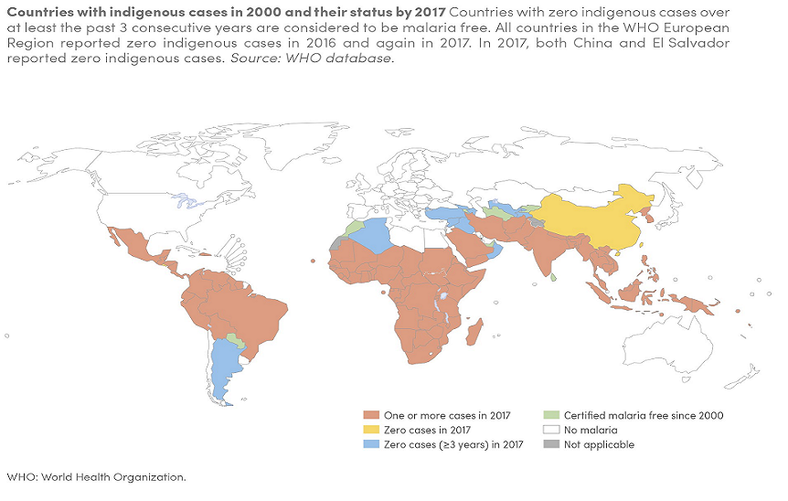

*Malaria Estimated Risk Heat Map* :[*https://www.who.int/gho/malaria/en/*](https://www.who.int/gho/malaria/en/)

The motivation for this project is however based on the nature and fatality of this disease. Initially if an infected mosquito bites you, parasites carried by the mosquito will get in your blood and start destroying oxygen-carrying RBCs. Typically the first symptoms of malaria are similar to the flu or a virus when you usually start feeling sick within a few days or weeks after the mosquito bite. Thus, a delay in the right treatment can lead to complications and even death.

Hence early and effective testing and detection of malaria can save lives.

Every 2 minutes, a child dies of malaria. And each year, more than 200 million new cases of the disease are reported. Although countries have dramatically reduced the total number of malaria cases and deaths since 2000, progress in recent years has stalled. Worryingly, in some countries, malaria is on the rise. In short, nearly half the world’s population is at risk from malaria and there are over 200 million malaria cases and approximately 400,000 deaths due to malaria every year. This gives us all the more motivation to make malaria detection and diagnosis fast, easy and effective.

### **"High burden high impact approach"**

At the World Health Assembly in May 2018, the WHO Director-General, Dr Tedros Adhanom Ghebreyesus, called for an aggressive new approach to jump-start progress against malaria. A new country-driven response – “ High burden to High impact” – was launched in Mozambique in November 2018.

The approach is currently being driven by the 11 countries that carry a high burden of the disease (Burkina Faso, Cameroon, Democratic Republic of the Congo, Ghana, India, Mali, Mozambique, Niger, Nigeria, Uganda and United Republic of Tanzania). Key elements include:

1. political will to reduce the toll of malaria;
2. strategic information to drive impact;
3. better guidance, policies and strategies; and
4. a coordinated national malaria response.

Catalysed by WHO and the RBM Partnership to End Malaria, “High burden to high impact” builds on the principle that no one should die from a disease that can be prevented and diagnosed, and that is entirely curable with available treatments.

## 

## 

## **SURVEY**

Currently, many countries with a high burden of malaria have weak surveillance systems and are not in a position to assess disease distribution and trends, making it difficult to optimize responses and respond to outbreaks.

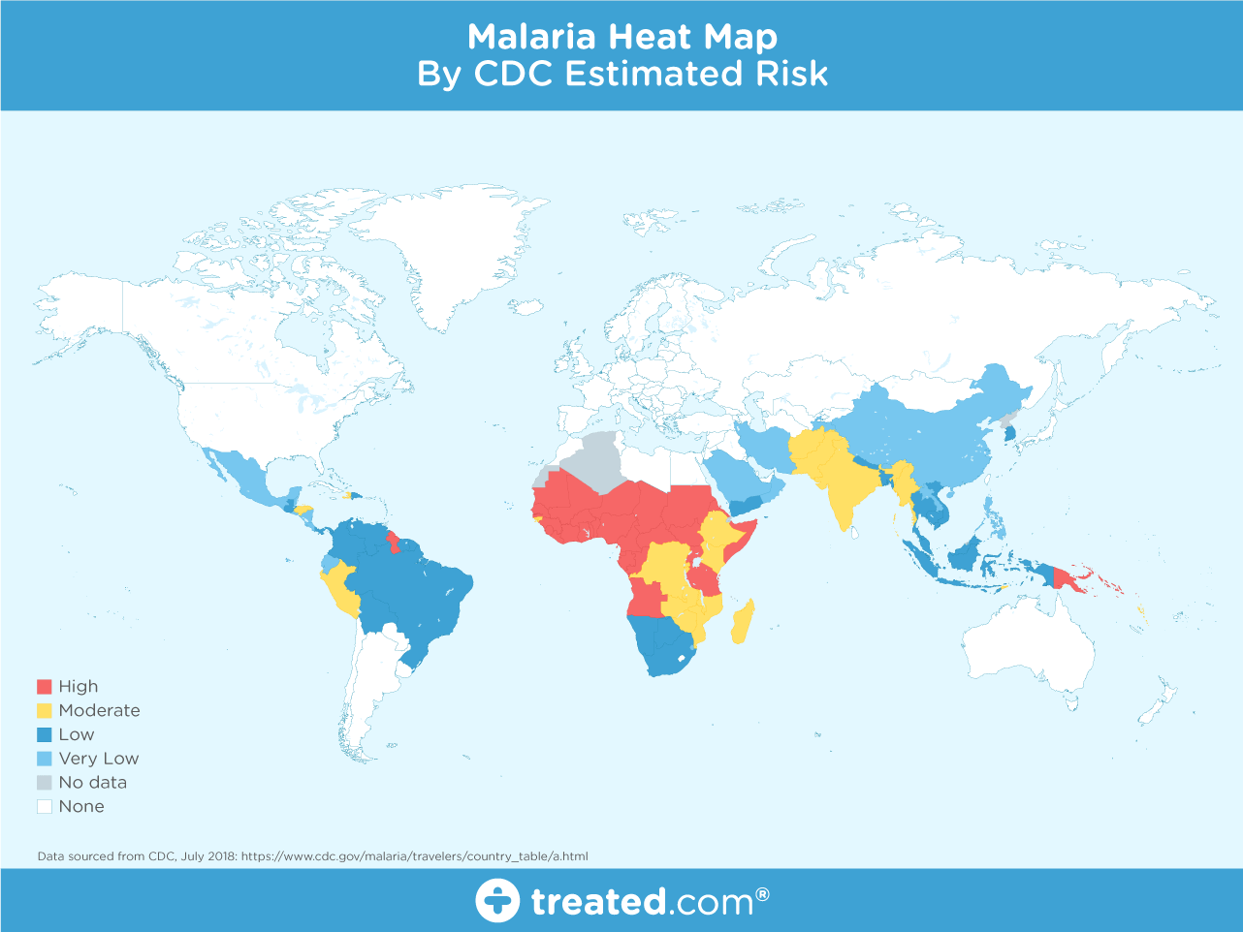

*Image source:* [*https://www.treated.com/malaria/world-map-risk*](https://www.treated.com/malaria/world-map-risk)

Effective surveillance is required at all points on the path to malaria elimination. Stronger malaria surveillance systems are urgently needed to enable a timely and effective malaria response in endemic regions, to prevent outbreaks and resurgences, to track progress, and to hold governments and the global malaria community accountable.

## **BROAD OBSERVATIONS**

Malaria is a highly occurring, vector borne disease in the equatorial region. It is a life-threatening disease caused by parasites that are transmitted to people through the bites of infected female Anopheles mosquitoes. It is preventable and curable.

It affects between 350 and 500 million people and causes more than 1 million deaths every year. There were an estimated 190311 million clinical episodes of malaria. It becomes the 5th cause of death from infectious diseases worldwide in low income countries. In 2018, there were an estimated 228 million cases of malaria worldwide. The estimated number of malaria deaths stood at 405,000 in 2018.

Children aged under 5 years are the most vulnerable group affected by malaria; in 2018, they accounted for 67% (272,000) of all malaria deaths worldwide. The WHO African Region carries a disproportionately high share of the global malaria burden. In 2018, the region was home to 93% of malaria cases and 94% of malaria deaths. Nearly 85% of global malaria deaths in 2018 were concentrated in 20 countries in the WHO African Region and India; Nigeria accounted for almost 24% of the global malaria deaths, followed by Democratic Republic of the Congo(11%), the United Republic of Tanzania(5%), and Angola, Mozambique and Niger(4% each).

Total funding for malaria control and elimination reached an estimated US$ 2.7 billion in 2018. Contributions from governments of endemic countries amounted to US$ 900 million, representing 30% of total funding.

Malaria remains one of the most widespread infectious diseases of mankind, with 40% of the world’s population at risk and more than 240 million infections each year. Recent estimates

indicate a staggering mortality rate of over 1.2 million deaths annually, of which the majority are children and pregnant women living in sub-Saharan Africa.

Despite the remarkable progress that has been made to reduce global malaria mortality by 29% in the past 5 years, malaria is still a serious global health problem.

## 

## **OBJECTIVES**

Malaria is a public health problem that affects remote areas worldwide. Climate change has contributed to the problem by allowing for the survival of Anopheles in previously uninhabited areas. The blood to be tested is placed in a slide and is observed under a microscope to count the number of infected RBC. An expert technician is involved in the examination of the slide with intense visual and mental concentration. This is a tiresome and time consuming process. The objective of this project is to develop a new, automated diagnostic system for detecting malaria. We use Giemsa-stained blood samples to identify the Plasmodium species. This model uses image processing and artificial intelligence techniques to identify Plasmodium parasites. The algorithm is based on image processing and automated based features concepts using transfer learning. The search scope of the learning algorithm is reduced noise in the preprocessing step by knowing morphological analysis of blood cells. We propose a low-cost, automated diagnostic system for malaria. Digital processing image techniques and a learning process based on artificial intelligence algorithms were combined to develop the model.

**Malaria Parasite Details:**

Five species of *Plasmodium* (single-celled parasites) can infect humans and cause illness:

* Plasmodium falciparum (or P. falciparum)
* Plasmodium malariae (or P. malariae)
* Plasmodium vivax (or P. vivax)
* Plasmodium ovale (or P. ovale)
* Plasmodium knowlesi (or P. knowlesi)

Falciparum malaria is potentially life-threatening. Patients with severe falciparum malaria may develop liver and kidney failure, convulsions and coma. Although occasionally severe, infections with *P. vivax* and *P. ovale* generally cause less serious illness, but the parasites can remain dormant in the liver for many months, causing a reappearance of symptoms months or even years later.

Malaria is spread when an infected *Anopheles* mosquito bites a person. This is the only type of mosquito that can spread malaria. The mosquito becomes infected by biting an infected person and drawing blood that contains the parasite. When that mosquito bites another person, that person becomes infected.

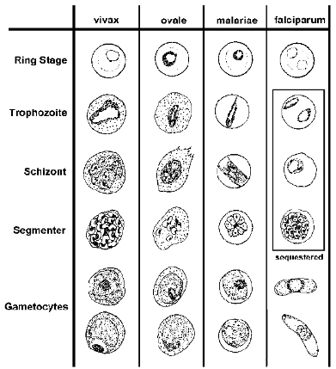

*Image Source:* [*https://www.tulane.edu/~wiser/protozoology/notes/pl_sp.html*](https://www.tulane.edu/~wiser/protozoology/notes/pl_sp.html)

**Dataset Details:**

The dataset consists of 27,588 images belonging to two separate classes:

1. **Parasitized:** Implying that the region contains malaria.
2. **Uninfected:** Meaning there is no evidence of malaria in the region.

The number of images per class is equally distributed with 13,794 images per each respective class.

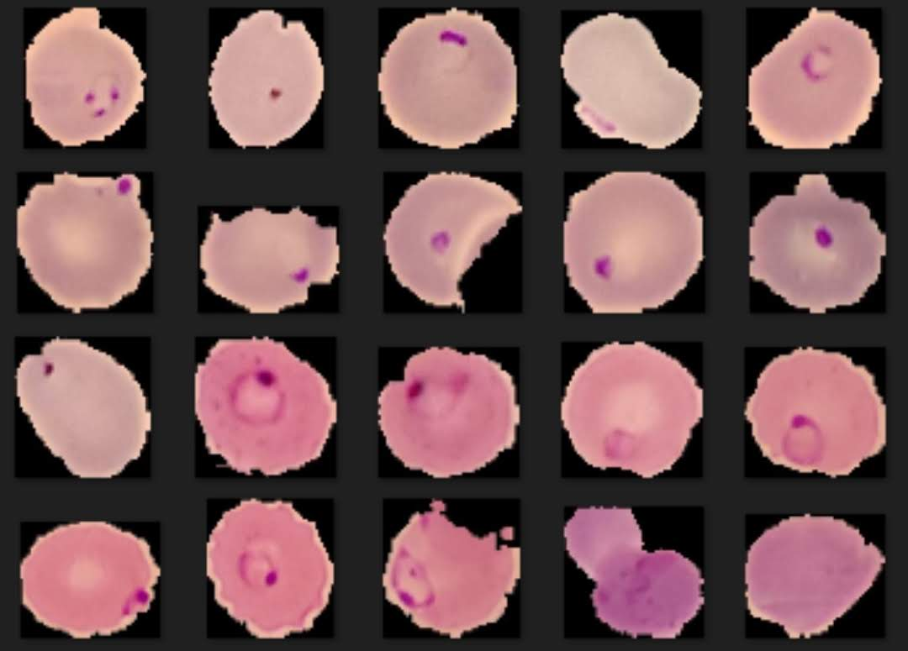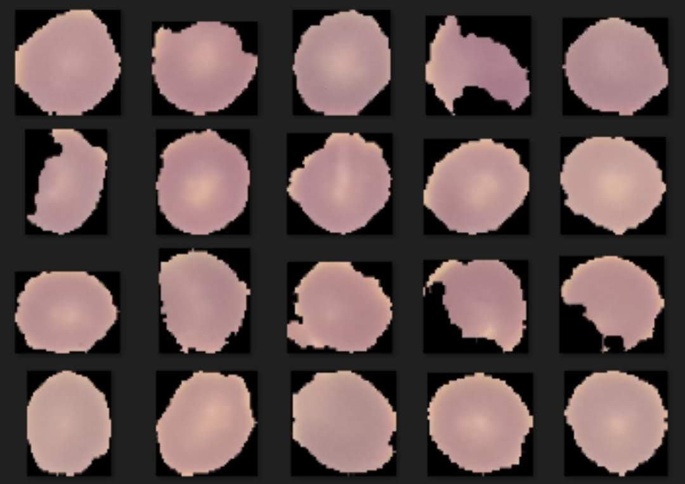

**Parasitized Uninfected**

The dataset itself can be found on the official NIH webpage. (<https://lhncbc.nlm.nih.gov/publication/pub9932>)

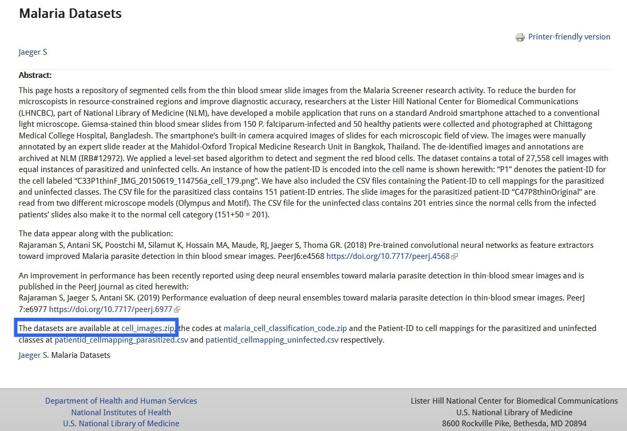

The National Institute of Health (NIH) has made their Malaria Dataset available to the publicon their website. We download the ***cell_images.zip*** file in our local machine.

## **WORKING PROCEDURES**

Image processing and Machine learning technologies have been used for automated diagnosis of malaria. We present some of our recent progress on highly accurate classification of malaria-infected cells using convolutional neural networks. First, we used image processing methods for analysis of red blood cells from dataset images. We then discuss the procedures of compiling a pathologists-curated image dataset for training neural networks, as well as data augmentation methods used to significantly increase the size of the dataset, in light of the overfitting problem associated with training convolutional neural networks. We will then compare the classification accuracies obtained by convolutional neural networks through training, validating, and testing with various combinations of the datasets. These datasets include the original dataset and the significantly augmented datasets, which are obtained using direct interpolation, as well as indirect interpolation using automatically extracted features provided by stacked autoencoders.

**Experimental Setup:**

All of these experiments were performed on a machine with Ubuntu 18.04 and Windows® system with Intel® Core(TM) i7-7700 CPU @2.40GHz processor, 1 TB HDD, 8 GB RAM, a CUDA-enabled Nvidia® GTX 1060 4 GB graphical processing unit (GPU), Python® 3.7.2, Keras® 2.2.4 with TensorFlow® 1.12.0 backend, and CUDA compilation tools, release 10.0, V10.0.130 dependencies for GPU acceleration.

### **1. Image Pre-processing Steps:**

The method of detection of malaria parasite is mainly subdivided into two parts first as the image recognition and second as the image classification and parasitemia estimation. Where an image is loaded the main step is image pre-processing to enhance the visual appearance of images and to improve the manipulation of the dataset. The enhancement technique can emphasize image artifacts or even leads to a loss of information if not correctly performed. Pre-processing is exerted to achieve objectives. The image is enhanced and then intensified image contrast is performed for better visual analysis. Image processing is performed on images. The obtained image is forwarded for further processing.

#### **1.1 Steps:**

**1.1.1 Image Acquisition:** The input images of Giemsa stained blood smears are selected from the database Library. Images are of different shapes and sizes. Images show high variations in intensity, contrast color tone etc.

**1.1.2 Image Pre-processing:** The pre-processing block is designed to remove unwanted effects from the image and to adjust the image as necessary for further processing. The microscopic input image is converted from RGB to grayscale to reduce the processing time. RGB to gray conversion is done by averaging all the three components i.e. R, G and B which results in grayscale.

**1.1.3 Image Smoothing:** Smoothing is often used to reduce noise within an image or to produce a less pixelated image. Most smoothing methods are based on low pass filters. Smoothing is also usually based on a single value representing the image, such as the average value of the image or the middle (median) value. The simplest approach is neighbor-hood averaging, where each pixel is replaced by the average of the value pixels contained in some neighborhood about it.

**1.1.4 Thresholding:** Thresholding is the simplest method which is applied on images. From a grayscale image, thresholding can be used to create binary images. The purpose of thresholding is to partition an image into meaningful regions with respect to a particular application.

**1.1.5 Dilation:** Dilation is one of the two basic operators in the area of mathematical morphology, the other being erosion. It is typically applied to binary images, but there are versions that work on grayscale images. The basic effect of the operator on a binary image is to gradually enlarge the boundaries of regions of foreground pixels. Thus areas of foreground pixels grow in size while holes within those regions become smaller.

#### **1.2 Flow-Chart:**



Preprocessing is done to make the images easy to be processed further as it removes the noise and other unwanted artifacts from the image under observation. The steps followed in preprocessing can be explained as in flowchart. Initially the RGB image is converted into the gray image. The basic Red, Green, and Blue (RGB) planes of the input image are separated so as to create object masks for segmentation. The RGB plane separation is done. As there are intensity variations all over the image and work on intensity factor, thresholding is the key requirement. Therefore, auto thresholding is done using Otsu’s method. An object mask is the image which is used as the standard sample to segment the region of interest in the input image and hence it should contain the parasitic part in the image. Therefore, considering all these aspects, the Hue, Saturation, and Value (HSV) bands are created. Combined GV band is obtained and named as an object mask. This object mask is used for further processing because it gives a good quality image containing all the RBC and parasites clearly visible. Finally, the morphological operations like closing and opening are performed on the object mask for removing the unwanted artifacts.

#### **1.3 Block Diagram:**



The method of detection of malaria parasite is mainly subdivided into two parts first as the image recognition and second as the image classification and parasitemia estimation. The proposed method follows the stepwise work as shown in the block diagram. The first block consists of the three basic steps of image processing, that is preprocessing, image smoothing & thresholding and morphological analysis. While in the image classification and detection of infected red blood cells that is called parasitemia separation of infected RBC carried out using machine learning algorithms.

### **2. Machine Learning Process:**

We have experimented with several preprocessing and post-processing techniques to analyze their effectiveness on malaria dataset. After performing morphological operation, collect features from the dataset although models converged faster when these processing techniques were applied. Pre-processing Results suggest that the features do not have to be in the same scale for the models to be trained. Pre-processing techniques increase the performance on malaria dataset. While this may seem counter-intuitive, we believe this is due to the fact that smoothing technique applied. General data augmentation techniques performed significantly better on the NIH Malaria dataset. Partial obstruction, drop-out was not performed in augmentation technique as these techniques might have removed parasite information from RBCs.

Post processing techniques such as ensemble and test time augmentation both have improved model performance. In order to check whether these models are biased to a specific test, different independent test sets were evaluated. Hence, our best performing models do not have larger variance from the validation sets.

#### **2.1 Data Pipeline:**

Normally, when we are working with the dataset, we would load those data into the memory (i.e. *pandas* data frame or *numpy* array). However, when we are working with other unstructured data or large amounts of data, we cannot fit all images into the memory (maybe we can but it will cost significantly). We will demonstrate the use of the *flow_from_directory()* method to feed the training image to the model. So we need to restructure the folders from what we currently have, below image demonstrates the thought process on this.





#### **2.2 Model Training Phase:**

In the model training phase, we will build several models and train them on our training data and compare their performance on the validation data. We will then save these models and use them later on again in the model evaluation phase.

**2.2.1 Pre-trained Model as a Feature Extractor:**

In this step, use the feature extractors which is most important. We load the feature extractor and get the expected image size. This will be used when we generate the data pipeline to feed the train, evaluation and test dataset. Next, we use the *flow_from_directory()* method. We then resize the image for all data generators to fit the feature extractor module. The training and validation generator will be shuffled because we want to feed the images randomly. We can then wrap the feature extractor with the classifier on top, specifically for our malaria classification task. We start training the network with our data set.

**2.2.2 Pre-trained Model with Image Augmentation:**

We will also introduce the concept of image augmentation. The idea behind image augmentation is exactly as the name sounds. We load in existing images from our training dataset and apply some image transformation operations to them, such as rotation, shearing, translation, zooming, and so on, to produce new, altered versions of existing images. Due to these random transformations, we don’t get the same images each time. We will leverage an excellent utility called *ImageDataGenerator* that can help us build image augmentors. All data generators will be scaled down to within [0, 1].



**2.2.3 Training and Test:**

In the model training phase, we will build several models and train them on our training data and compare their performance on the validation data. We will then save these models and use them later on again in the model evaluation phase. Our malaria detection model will be building and training a basic convolutional neural network (CNN). We get a clear perspective by plotting the training and validation phase and save this model for future evaluation.

This completes our model training phase and we are now ready to test the performance of our models on the actual test dataset. We will now evaluate the models that we built in the training phase by making predictions with data and perform in the test dataset. We will be using it to evaluate the performance of our models with relevant classification metrics. The first step here is to obviously scale our test data. The next step involves loading up our saved models and making predictions on the test data.



## **RESULT EVALUATION**

We have utilised image smoothing and thresholding processes. The results show that the morphological analysis of images in the dataset. The evaluations here do not suggest concatenated features necessarily yield better results and that adding features to them slightly improves the performance. To improve the efﬁciency of the method malaria parasite detection and to reveal the actual performance of more controlled experiments.

Now we will discuss the second phase of the model. We trained the model for a total of 12 epochs.

* 96.50% accuracy on the *training* data
* 96.78% accuracy on the *validation* data
* 97% accuracy on the *testing* data



To start, our model is a complete end-to-end malaria classification system. This result is better because a multiple step process of feature extraction from multiple models and classification, we instead can utilize only a single, compact model and obtain comparable results. This phase works in a faster manner and model size is very compact. The model is faster in terms of forward-pass inference time and significantly fewer parameters and memory/hardware requirements.

## **SCOPE FOR FUTURE WORK**

## Medical imaging analysis is going to be one of the most emerging branches. Artificial intelligence is being researched extensively. Morphological analysis of image is the future of medicine. Artificial intelligence will help to save time and an imaging analyst is essential for development and quality control of such softwares. This type of effort most important because

1. This type of technique avoids the need for manual selection of the suspected region window.
2. In addition, this technique evaluates the findings by proven statistical technique to authenticate the accuracy of the detection methods.
3. These methods are used for other medical image processing applications with machine learning models. The proposed technique is acceptably accurate, promising and comparable with any other standard methods and in future the work aims in attaining higher accuracy.

For medical imaging practitioners, the future that includes an ‘AI work colleague’ may represent a scary or exciting concept. Diagnostic analysts will have an important role to play in building quality imaging biobanks, the databases that feed the AIs and the development of national systems that collect and manage these repositories. In the same way that AI is being developed to provide personalised quantification of risk of disease or wellness, AIs can be developed to personalise imaging protocols for modalities such as CT, MRI and molecular imaging and this is where diagnostics may adopt a role in optimising AIs. A further important capability is the ability to recognise the limitations and biases of AIs and to identify and apply its best features in an ethically appropriate way. AIs, like all trained machine learning, have the capability to lead to adverse outcomes for patients.

## 

## **CONCLUSION**

As the number of people infected by malaria in tropical regions is high, there is a special need for early diagnosis of malaria parasites, for its prevention against getting into the next stage and medication of a person. Malaria parasite detection by itself is not an easy procedure and the availability of the right personnel across the globe is also a serious concern. We presented an automated diagnosis of the malaria parasite in blood images. We looked at easy to build open-source techniques leveraging AI which can give us state-of-the-art accuracy in detecting malaria thus enabling AI for social good. AI capabilities across healthcare making it cheaper and accessible for everyone across the world.

**REFERENCES**

1. <http://www.malaria.com>
2. <http://www.who.int/topics/malaria/en/>
3. <https://www.who.int/southeastasia>
4. https://www.who.int/publications-detail/world-malaria-report-2019
5. <https://www.who.int/gho/malaria/en/>
6. <http://www.anytestkits.com/malaria-test-kit.htm>
7. <https://lhncbc.nlm.nih.gov/publication/pub9932>
8. <https://arxiv.org/ftp/arxiv/papers/1907/1907.10418.pdf>
9. <https://www.cdc.gov/malaria/travelers/country_table/i.html>
10. <https://www.cdc.gov/parasites/malaria/index.html>
11. <https://www.treated.com/malaria/world-map-risk>
12. <https://www.ncbi.nlm.nih.gov/pmc/articles/PMC4407949>
13. <https://www.tulane.edu/~wiser/protozoology/notes/pl_sp.html>
14. <https://www.who.int/malaria/publications/atoz/high-impact-response/en/>
15. <https://cs231n.github.io/convolutional-networks/>
16. R.C. Gonzalez, R. E. Woods, Digital Image Processing. Third Edition, Pearson Education
17. Das D, Mukherjee R, Chakraborty C. Computational microscopic imaging for malaria parasite detection: a systematic review. JMicrosc 2015;260:1–19.
18. Devi SS, Sheikh SA, Laskar RH. Erythrocyte features for malaria parasite detection in microscopic images of thin blood smear: a review. Int J Interact Multimedia Artificial Intell 2016;4:34–9.
19. Suwalka I, Sanadhya A, Mathur A, Chouhan MS. Identify malaria parasites using pattern recognition techniques. In: International Conference on computing, communication and applications. IEEE;2012:1–4.
20. Anggraini D, Nugroho AS, Pratama C, Rozi IE, Pragesjvara V,Gunawan M. Automated status identification of microscopic images obtained from malaria thin blood smears using Bayes Decision: a study case in Plasmodium falciparum. In: International Conference on advanced computer science and information system.IEEE; 2011:347–52
21. Rahmat Romi S Wulandari, F & Faza, S & A Muchtar, M & Siregar and Ikhsan, “The Morphological classification of normal and abnormal red blood cell using self-Organizing Map”, IOP Conference Series: Materials Science and Engineering 2015.
22. A. Ms. Deepali Ghate, “Automatic Detection Of malaria parasite from blood images”, International Journal of advanced computer Technology,IJACT,Valume4,Number1.
23. D. Das et al., “Probabilistic prediction of malaria using morphological and textural information,” in IEEE Int. Conf. on Image Information Processing, pp. 1–6 (2011).